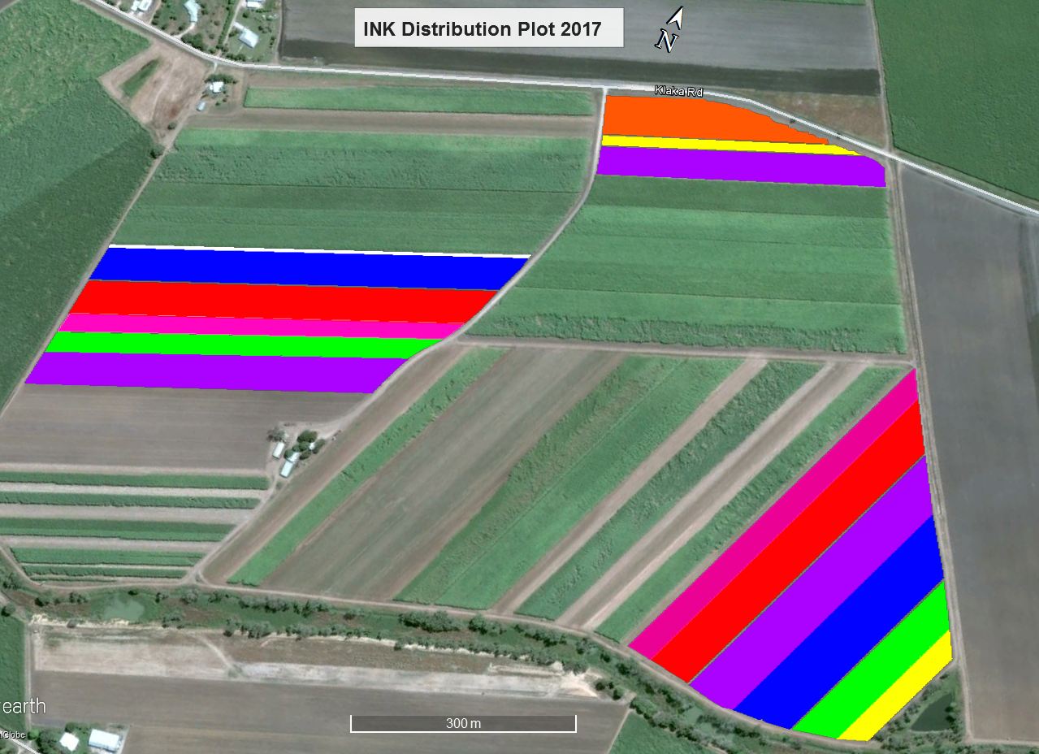

Q183 34 Drills 3.28Ac 1.33Ha

Q253 17 Drills 1.12 Ac 0.45 Ha

Q240 48 Drills 5.88 Ac 2.38 Ha

Q252 44 Drills 7.16 Ac 2.9 Ha

KQ228 42 Drills 7.73 Ac 3.13 Ha

Break Row

Break Row

Q208 15 Drills 3.17 Ac 1.28 Ha

Q252 24 Drills 3.36 Ac 1.36 Ha

Break Rows

Q253 12 Drills 1.23 Ac 0.5 Ha

Q232 26 Drills 3.00 Ac 1.23 Ha

Break Row

Break Row

Q252 27 Drills 5.1 Ac 2.1 Ha

Q183 17 Drills 3.24 Ac 1.31 Ha

Q208 12 Drills 3.00 Ac 1.23 Ha

KQ228 24 Drills 6.00 Ac 2.44 Ha

Q240 25 Drills 6.00 Ac 2.43 Ha

Q238 1 Drills 0.53 Ac 0.21 Ha

**Inkerman Distribution Plot 1st Ratoons 2018**