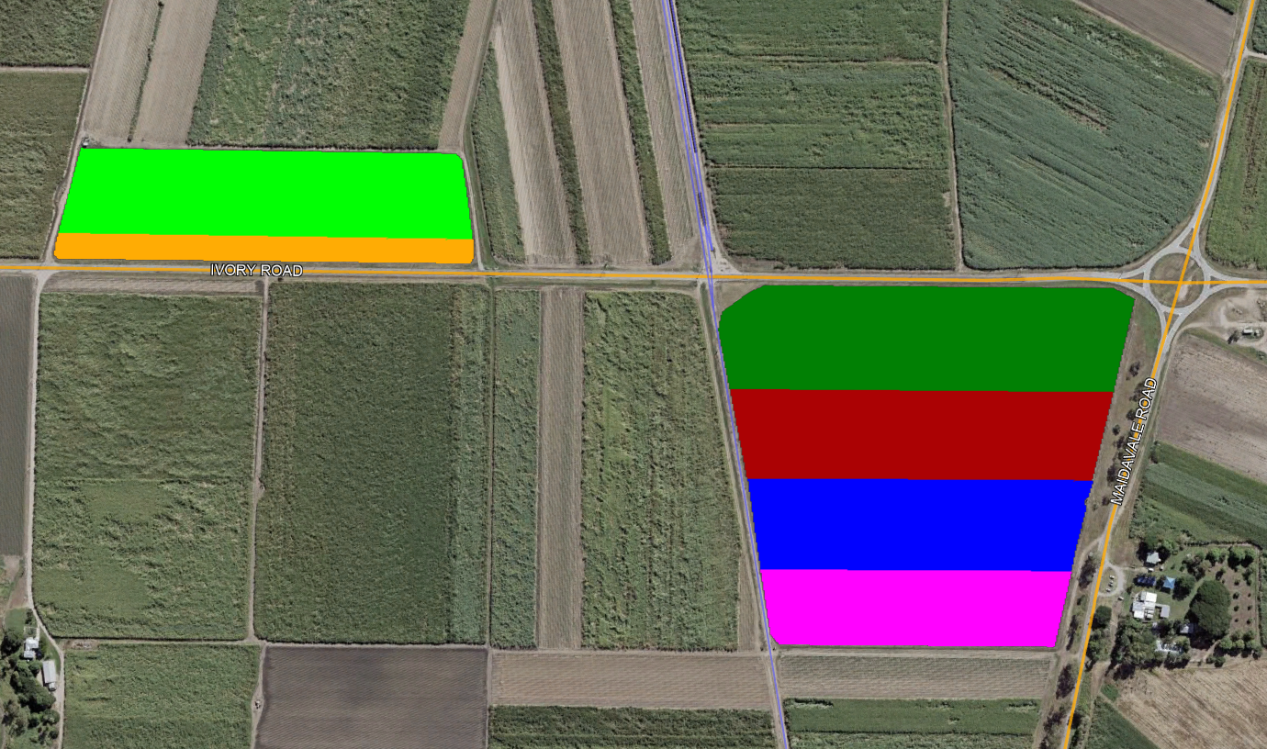

EX-SRA8 Fallow 73 Drills 4.72ha 11.7ac

Q208 52 Drills 2.5ha 6.17ac

Q240 64 Drills 3.38ha 8.34ac

KQ228 62 Drills 3.7ha 9.13ac

Q183 60 Drills 3.94ha 9.74ac

Q232 17 Drills 1.17ha 2.9ac

**P & K Distribution Plot 1st Ratoons 2018**