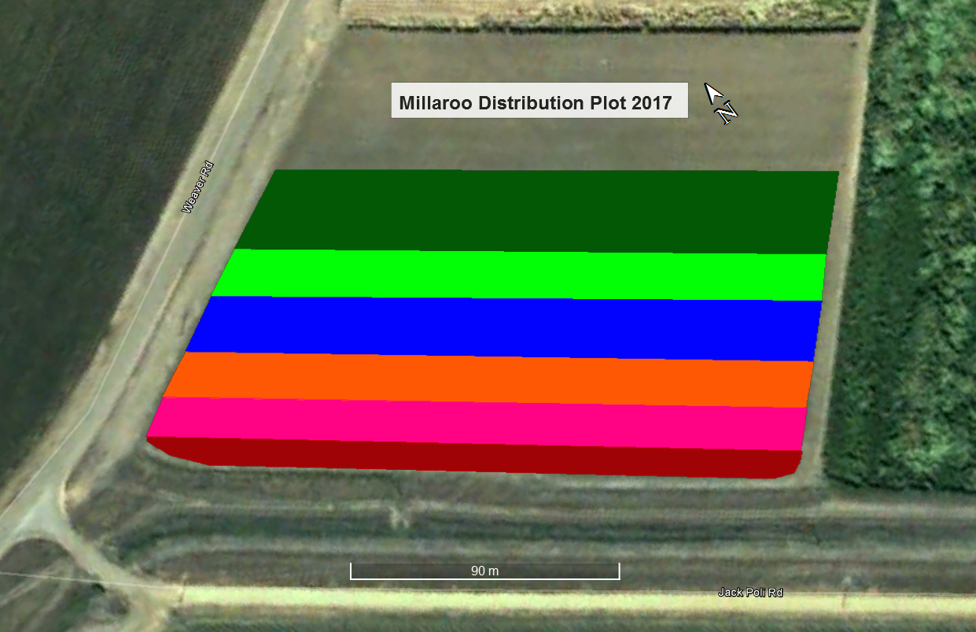

KQ228 6 Drills 0.48Ac 0.2Ha

Q208 8 Drills 0.73Ac 0.3Ha

Q232 10 Drills 0.74Ac 0.3Ha

Q240 12 Drills 0.98Ac 0.44Ha

Q183 10 Drills 0.74Ac 0.75Ha

SRA 8 17 Drills 1.24Ac 0.5Ha

Break Row